|  |  |
| --- | --- |
|  | **MINISTRY OF**  **EDUCATION AND TRAINING** |

**CAPSTONE PROJECT REPORT**

**Report 5 – Software Testing Documentation**

- Hanoi, December 2021 -

Table of Contents

Acronyms and Definitions 1

Record of changes 1

Report V. Software Testing Documentation 2

1. Scope of Testing 2

2. Test Strategy 2

2.1. Test Model 2

2.2. Testing Types 3

2.3. Test Levels 4

2.4. Supporting Tools 4

3. Test Plan 5

33.1. Human Resources 5

3.2. Test Milestones 5

4. Test Cases 6

4.1. Unit Test 6

4.2. Integration Test 8

4.3. System Test 8

4.4. Defect & Bug Log 9

4.5. Acceptance Test 10

5. Test Reports 11

5.1. Unit Test 11

5.2. Integration Test 13

5.3. System Test 14

# Acronyms and Definitions

|  |  |  |
| --- | --- | --- |
| **#** | **Acronym** | **Definition** |
|  |  |  |

Acronyms and Definitions Table

# Record of changes

|  |  |  |  |
| --- | --- | --- | --- |
| **Date** | **Status** | **In charge** | **Change description** |
| 11/20/2021 | A | VietNH | Add all heading for report |
| 12/16/2021 | M | VietNH | Complete Scope of Testing |
| 12/17/2021 | M | VietNH | Complete Test Strategy, Test Plan, Test Cases, and Test Reports |

A – Added, M – Modified, D – deleted

# Report V. Software Testing Documentation

## 1. Scope of Testing

* The team will focus mainly on functions that actor “Angler” will be executed.
* There are 4 phases in the testing process: Unit testing, Integration testing, System testing, and Acceptance testing.

|  |  |  |
| --- | --- | --- |
| **Test stages** | **Description** | **Purpose** |
| Unit testing | It is used to test function in backend code, created, and performed in source code by backend developers. | Re-check all requirements and cases that might be happened to a function and check if it can adapt them or not. |
| Integration testing | Group all individual modules and test as a group. It is created and performed by tester team. | To expose defects in the interfaces or defects in the interaction between integrated modules. |
| System testing | It is used to test a complete integrated system. It is created and performed by tester team. | To test overall system and verify all logic and data stream of system. |
| Acceptance testing | It conducted to determine if the requirements of a specification or are met. | Including alpha testing. Supervisor, team members and people who want to use the app can test builded app to detect bug and strange behavior. |

Table 1. Stages of testing

## 2. Test Strategy

### 2.1. Test Model

Our test type is an Interative Model. According to the model of the development process in Agile Model (an interative software development process framework). The Interative Model interates the requirement, design, implementation, testing and deployment phase continuously for each requirement and builds up the system iteratively till it is completely build.

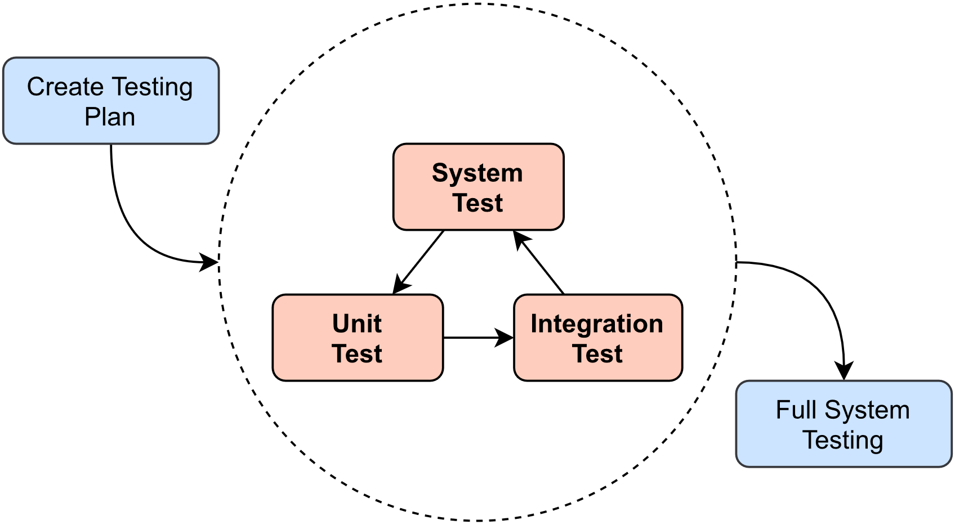

Figure 2.1. Interative Test Model

### 2.2. Testing Types

|  |  |
| --- | --- |
| **Testing Type** | **Description** |
| Functional Testing | * Testing individual methods, functions, model class and library class. * Test case will have to cover all logic branch that function or method could execute with difference data input. Another alternative logic branch should be covered if not, that logic branch should be detected at API testing level. * Implemented function’s error message and database error message will be included in this test. |
| GUI Testing | * GUI testing verifies a user’s interaction with the software. The goal of GUI testing is to ensure that the GUI provides the user with an appropriate access and navigation through the functions of the target-of-test. In addition, GUI testing ensures that the objects within the GUI function as expected and conform to requirement * GUI test will be performed fully on all screens. * This test targets to cover the verification of the overall look and feel of the system including initial position, font, text size, color, focus, initial button, tab order, label, etc. |
| API Testing | * Involves testing APIs directly to determine if they meet expectations for functionality, reliability, performance, and security. API testing will test all of individual implemented API of system API Service. |
| Regression Testing | * The testing is to confirm that the bug was removed including the extent of the impact, when developers fix bug, developers and testers will confirm with each other what is the impacts of fix bug modification, after that all impact unit or function will be retested by developers then testers after that. |
| Acceptance Testing | * This test type will be executed by tester with designed test cases, acceptance test is a test type conducted to determine if the requirements of a specification or contract are met. * It also includes alpha testing; alpha testing takes place at close relation user’s site and are free test to detect bug and strange behavior. By that, development team will improve UX and UI of system. |

Table 2.2. Testing Types

### 2.3. Test Levels

|  |  |  |  |  |
| --- | --- | --- | --- | --- |
| **Type of Tests** | **Test level** | | | |
| **Unit test** | **Integration Test** | **System Test** | **Acceptance Test** |
| Functional Testing | x | x | x |  |
| GUI Testing |  | x | x | x |
| API Testing | x |  | x |  |
| Regression Testing | x | x | x | x |
| Acceptance Testing |  |  |  | x |

Table 2.3. Test Levels

### 2.4. Supporting Tools

|  |  |  |  |  |
| --- | --- | --- | --- | --- |
| **Purpose** | **Type** | **Tool** | **Provider** | **Version** |
| Manage test cases | Software | Microsoft Excel | Microsoft | Professional Plus 2019 |
| Test APIs | Software | Postman[1] | Postman, Inc | Latest |
| Test function | Software | IntelliJ, Visual Studio Code | JetBrains, Microsoft | Latest |
| Execute integration and system test | Hardware | LENOVO Thinkpad, Razor |  | Window 10 |
| Database management | Software |  |  | Latest |

Table 2.4. Supporting Tools

## 3. Test Plan

### 33.1. Human Resources

|  |  |  |
| --- | --- | --- |
| **Member** | **Role** | **Specific Responsibility** |
| VietNH | Test leader  Tester | * Create test plan, test process, test case. * Create and execute unit test. * Execute test. * Log bug. * Create reports. |
| CuongLM | Tester  Frontend developer | * Execute test. * Fix bug of frontend features. * Log bug. |
| LongNV | Backend developer | * Fix bug of backend features. * Log bug. |
| SonND | Frontend developer | * Fix bug of frontend features. * Log bug. |

Table 3.1. Human Resources

### 3.2. Test Milestones

|  |  |  |
| --- | --- | --- |
| **Milestone Tasks** | **Start Date** | **End Date** |
| Create test cases (Iteration 1) | 11/18/2022 | 12/05/2022 |
| Execute Unit test and Integration test (Iteration 1) | 11/18/2022 | 12/05/2022 |
| Create test cases (Iteration 2) | 11/18/2022 | 12/05/2022 |
| Execute Unit test and Integration test (Iteration 2) | 11/18/2022 | 12/05/2022 |
| Update testing document | 11/29/2022 | 12/05/2022 |
| Execute System testing | 11/29/2022 | 12/05/2022 |
| Execute Acceptance testing with fixing bugs | 11/29/2022 | 12/05/2022 |
| Create test reports | 12/06/2022 | 12/14/2022 |

Table 3.2. Test Milestones

## 4. Test Cases

### 4.1. Unit Test

Functional testing will be done on server development side by backend developer, we use Junit libraries, which have been integrated in Spring Boot. These help to reduce test environment installation and can create function test in the most optimal way. For API testing, we use Postman, one of the most popular API testing platforms today, with a simple, easy-to-use interface, clear, and effective results for each test link.

Figure 4.1:1. samples of testing function.

Figure 4.1:2. Running unit test functions

Figure 4.1:3. API testing with Postman Platform

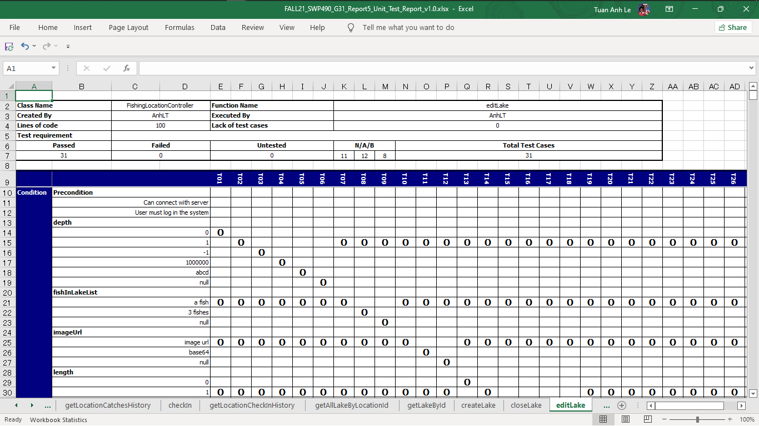

Figure 4.1:4 Functional test tracking

### 4.2. Integration Test

This stage of testing will incorporate the API into the app's interface to test what the data represents to the user. Each test case will clearly record the steps to execute a test case so that bugs or defects can be detected. During testing, if any errors related to UX/UI are discovered, the data representation is incorrect (both user and server side), or maybe the API returns data that is not as expected. Testers will log defect or bug on Jira Issues, and track that test case is failed until it will be fixed by developers.

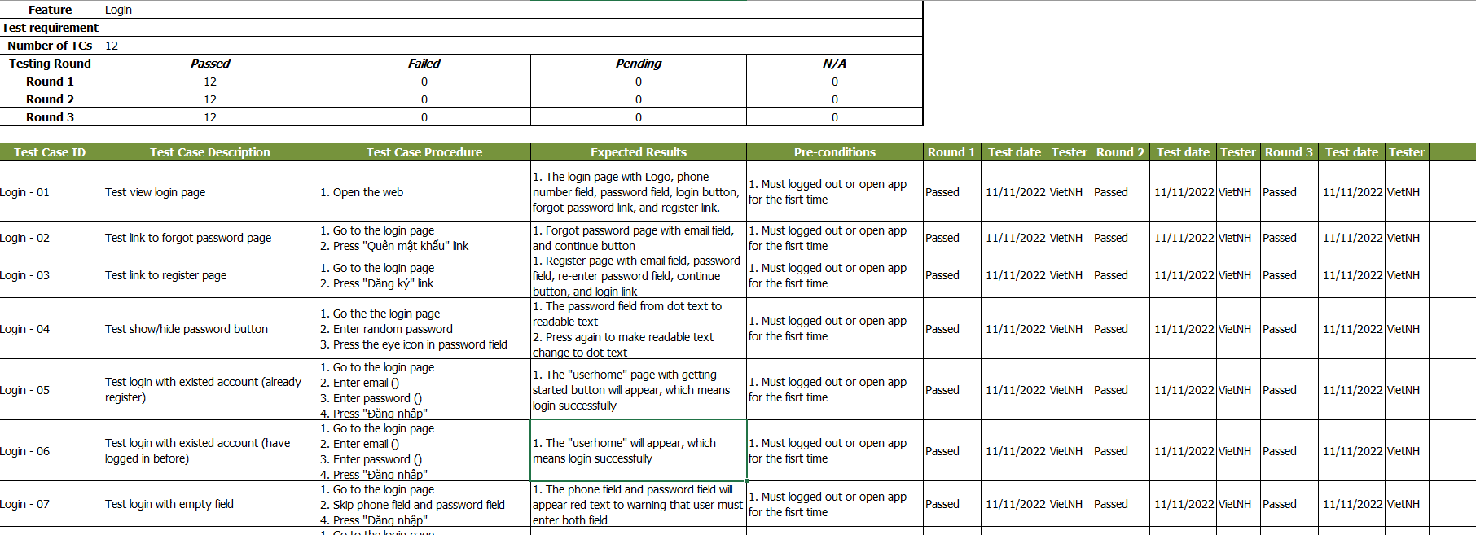

Figure 4.2. Integration test tracking

### 4.3. System Test

This stage of testing is performed after the functions outlined in the requirement are fully implemented. We will practice on a physical phone with Window 10 and 11 operating systems. The goal of this test phase is to test the performance that can be run on the device, and assuming the cases that the user will operate on application. Unlike unit testing and integration testing, if any defect or bug is found, the tester needs to notify the developer to fix it immediately or in the shortest time possible.

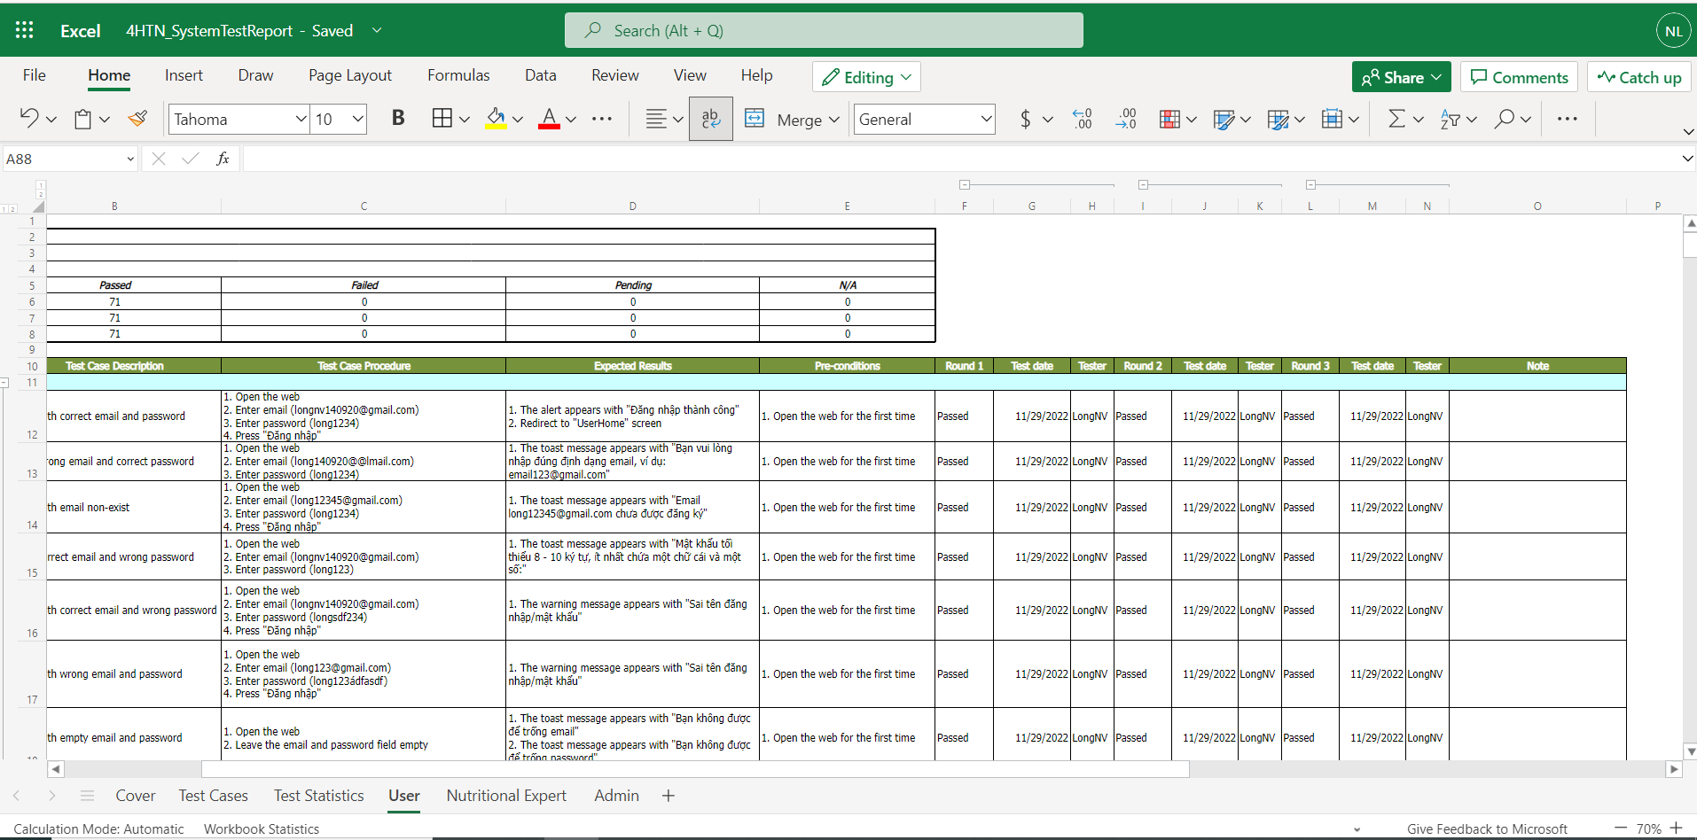

Figure 4.3. System test tracking

### 4.4. Acceptance Test

Our project will use the checklist as a substitute for acceptance testing including items from non-functional requirement specified in Software Requirement Specification.

The content of the checklist is shown in the table below:

|  |  |  |  |
| --- | --- | --- | --- |
| **ID** | **Checklists** | **Yes** | **No** |
| **General** | | | |
| CL-01 | Text on all screens are grammatically correct | x |  |
| CL-02 | All mandatory fields are validated | x |  |
| CL-03 | All error messages are displayed in red colour | x |  |
| **GUI and Usability** | | | |
| CL-04 | Links, buttons, and checkboxes are easily clickable | x |  |
| CL-05 | User interface should be clear and easy to use | x |  |
| CL-06 | The system must be designed so that users can easily familiarize themselves with and use competently functions in a short time | x |  |
| CL-07 | Main functions are organized into navigator for easier access | x |  |
| CL-08 | The maximum steps to complete 1 activity from seeing the screen is 3 | x |  |
| **Security** | | | |
| CL-09 | Using authentication and authorization to access protected resources. | x |  |
| CL-10 | JWT token is used to authenticate user. | x |  |
| CL-11 | Password must be protected and encrypt before store in database. | x |  |
| CL-12 | User's password must be hashed with Bcrypt. | x |  |
| CL-13 | Only send the latest OTP to the user's phone number. | x |  |
| **Performance** | | | |
| CL-14 | In the best condition, the slowest response is not exceeded 5 seconds. | x |  |
| CL-15 | In the best condition, the loading pages time must not exceed 5 seconds. | x |  |
| **Maintaining & Scalability** | | | |
| CL-16 | System logs error reporting to track errors whenever the application happens to crash. | x |  |
| CL-17 | Source code must follow the coding convention to help developers to read, understand, and find it easy to maintain or modify the code. | x |  |
| **Compatibility** | | | |
| CL-18 | The device must be Window 10 or higher. | x |  |
| **Localization** | | | |
| CL-19 | The language is Vietnamese. | x |  |
| CL-20 | The application only accepts Vietnamese phone number. | x |  |
| CL-21 | The date format in the application must be: dd/MM/yyyy or dd/MM/yyyy HH:mm:ss. | x |  |

Table 4.5. Acceptance Testing Checklist

## 5. Test Reports

### 5.1. Unit Test[2]

|  |  |  |  |  |  |  |  |
| --- | --- | --- | --- | --- | --- | --- | --- |
| **Function code** | **Passed** | **Failed** | **Untested** | **N** | **A** | **B** | **Total Test Cases** |
| **Sub total** |  |  |  |  |  |  |  |

Table 5.1. Unit Test Report

* Test coverage: **%**
* Test successfully coverage: **%**
* Normal case: **%**
* Abnormal case: **%**
* Boundary case: **%**

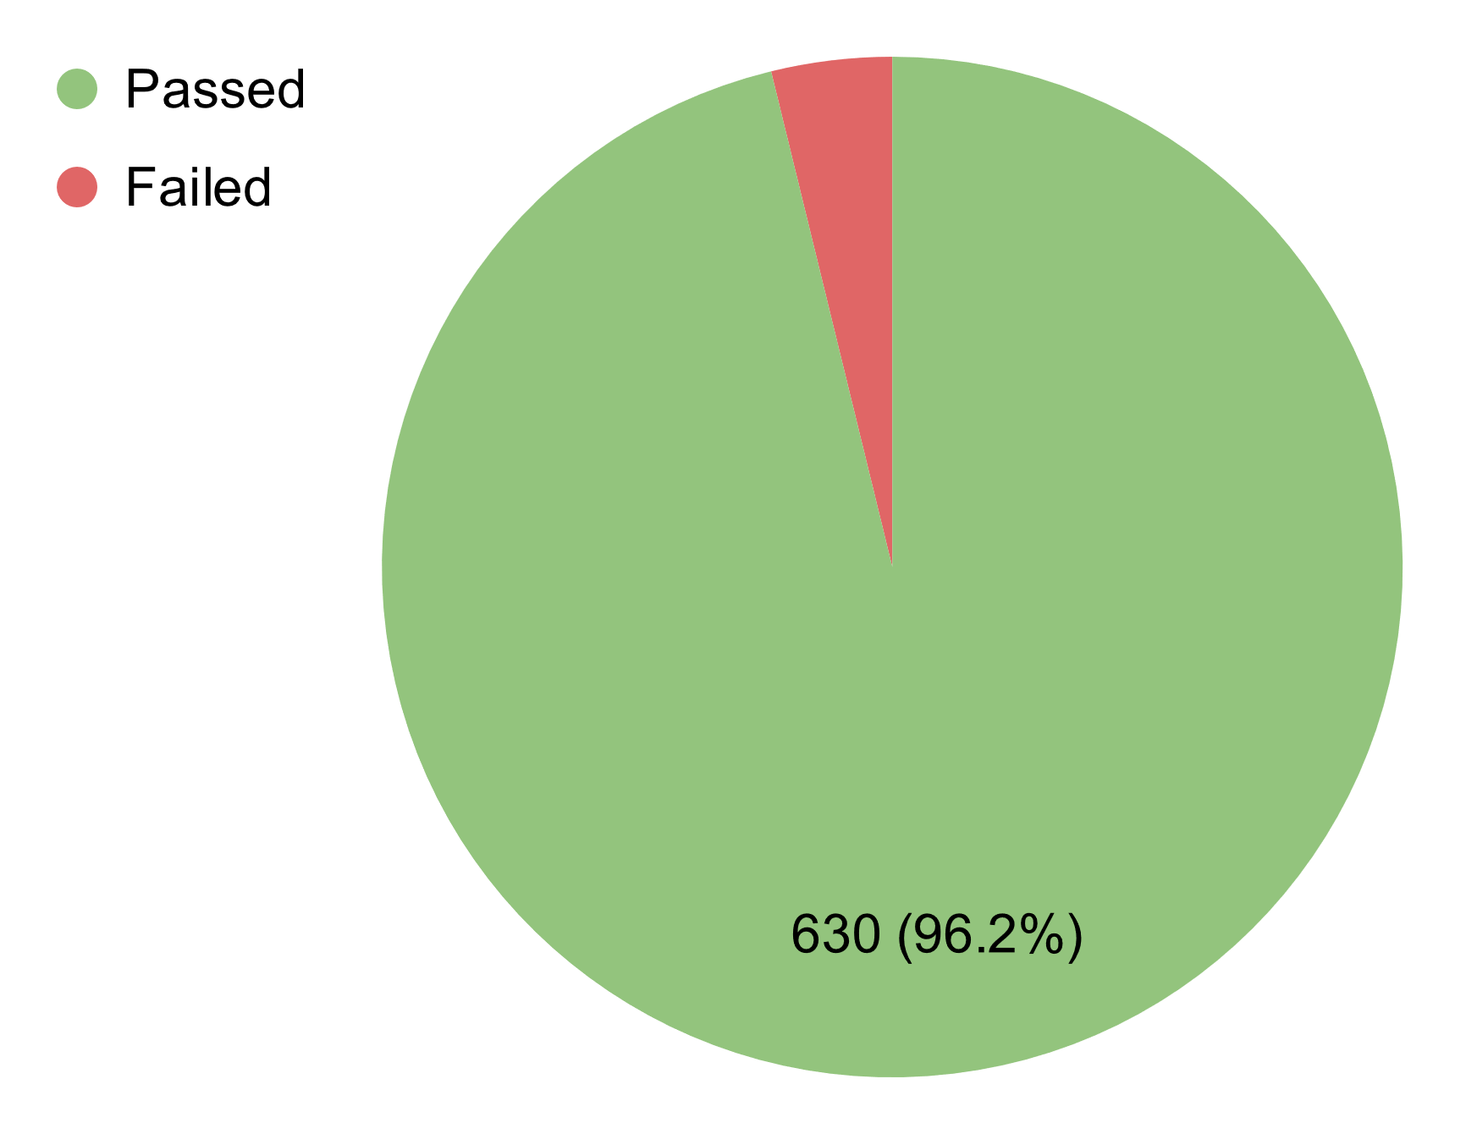 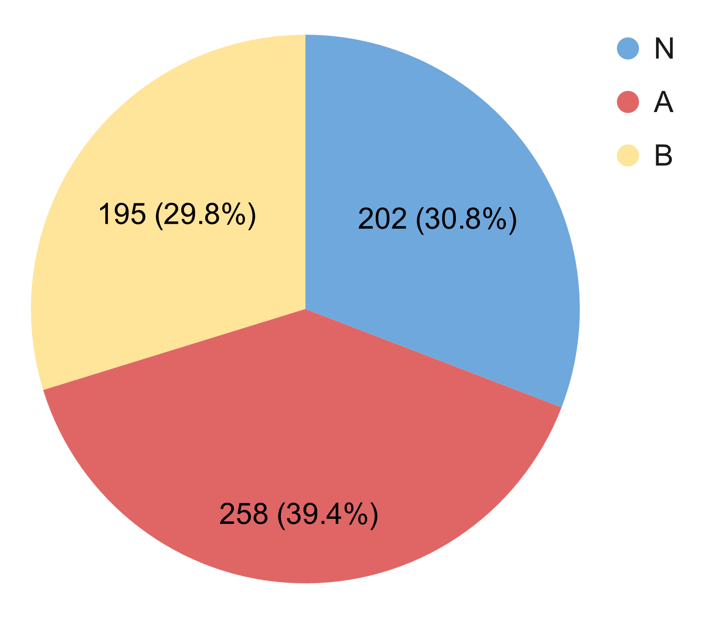

Figure 5.1:1, 5.1:2. Passed Percent & Test Type

### 5.2. Integration Test[3]

Table 5.2. Integration Test Report

* Test coverage: **100%**
* Test sucessfully coverage: **97.77%**

### 5.3. System Test[4]

Table 5.3. System Test Report

* Test coverage: **100%**
* Test sucessfully coverage: **100%**

1. [Postman API Platform](https://www.postman.com/)
2.
3.
4.